2 February, 2022

Vol. 32, No. 11

For Additional Information:
Dr. John Christy, (256) 961-7763
christy@nsstc.uah.edu
Dr. Roy Spencer, (256) 961-7960
spencer@nsstc.uah.edu

Global Temperature Report: February 2022

Global climate trend since Dec. 1 1978: +0.13 C per decade

February Temperatures (preliminary)

Global composite temp.: +0.00 C (+0.00°F) equal to seasonal average

Northern Hemisphere: +0.01 C (+0.02 °F) above seasonal average

Southern Hemisphere: -0.02 C (-0.04 °F) below seasonal average

Tropics: -0.24 C (-0.43 °F) below seasonal average

January Temperatures (final)

Global composite temp.: +0.03 C (+0.05°F) above seasonal average

Northern Hemisphere: +0.06 C (+0.11 °F) above seasonal average

Southern Hemisphere: +0.00 C (+0.00 °F) equal to seasonal average

Tropics: -0.24 C (-0.43 °F) below seasonal average

Notes on data released March 2, 2022 (v6.0, with 1991-2020 reference base)

The global temperature departure from average in February was zero, or +0.00 °C (0.00°F). Both hemispheres were also virtually zero in their departure from normal while the La Niña-cooled tropics remained at -0.24 C (-0.43 °F). Global cooling associated with the on-going presence of La Niña typically reaches its coolest point in the months of February to April, and this may be unfolding in 2022. The latest on the evolution of La Niña and its anticipated diminishment is provided by NOAA here:
https://www.cpc.ncep.noaa.gov/products/analysis_monitoring/lanina/enso_evolution-status-fcsts-web.pdf.

The planet’s warmest region, in terms of the monthly departure from average, was over northern Russia in the Bulunsky District where one grid cell hit +4.6 °C (+8.2 °F) above normal. The pattern of warm and cold anomalies is related to the influence of the La Niña-induced cooling in the tropics. Other warm areas were experienced in the western North Atlantic, eastern North Pacific, Europe and western Asia with alternating regions in the far southern oceans.

Paamiut off the SW coast of Greenland experienced the coldest departure from average at -5.2 C (-9.3 °F) and was surrounded by other similarly cold regions. China experienced largely colder than normal temperatures as did the broad eastern tropical Pacific (La Niña), central US and eastern Australia.

The large-scale pattern this month favored cool temperature over the central conterminous US and warmth along both coasts. On average then, the 48-state temperature came out near zero at -0.05 °C (-0.09 °F). Alaska was a bit warmer than usual overall, influencing the 49-state average to be just above the zero line at +0.08 °C (+0.14 °F). [We don’t include Hawaii in the US results because its land area is less than that of a satellite grid square, so it would have virtually no impact on the overall national results.]

New Reference Base Jan 2021 and forward. As noted in the Jan 2021 GTR, the situation comes around every 10 years when the reference period or “30-year normal” that we use to calculate the departures is redefined. With that, we have averaged the absolute temperatures over the period 1991-2020, in accordance with the World Meteorological Organization’s guidelines, and use this as the new base period. This allows the anomalies to relate more closely to the experience of the average person, i.e. the climate of the last 30 years. Due to the rising trend of global and regional temperatures, the new normals are a little warmer than before, i.e. the global average temperature for Januaries for 1991-2020 is 0.14 °C warmer than the average for Januaries during 1981-2010. So, the new departures from this now warmer average will appear to be cooler, but this is an artifact of simply applying a new base period. It is important to remember that changes over time periods, such as a trend value or the relative difference of one year to the next, will not change. Think about it this way, all we’ve done is to take the entire time series and shifted it down a little.

To-Do List: There has been a delay in our ability to utilize and merge the new generation of microwave sensors (ATMS) on the NPP and JPSS satellites. As of now, the calibration equations applied by the agency have changed at least twice, so that the data stream contains inhomogeneities which obviously impact the type of measurements we seek. We are hoping this is resolved soon with a dataset that is built with a single, consistent set of calibration equations. In addition, the current non-drifting satellite operated by the Europeans, MetOP-B, has not yet been adjusted or “neutralized” for its seasonal peculiarities related to its unique equatorial crossing time (0930). While these MetOP-B peculiarities do not affect the long-term global trend, they do introduce error within a particular year in specific locations over land.

As part of an ongoing joint project between UAH, NOAA and NASA, Christy and Dr. Roy Spencer, an ESSC principal scientist, use data gathered by advanced microwave sounding units on NOAA, NASA and European satellites to produce temperature readings for almost all regions of the Earth. This includes remote desert, ocean and rain forest areas where reliable climate data are not otherwise available. Drs. Danny Braswell and Rob Junod assist in the preparation of these reports.

The satellite-based instruments measure the temperature of the atmosphere from the surface up to an altitude of about eight kilometers above sea level. Once the monthly temperature data are collected and processed, they are placed in a "public" computer file for immediate access by atmospheric scientists in the U.S. and abroad.

The complete version 6 lower troposphere dataset is available here:

http://www.nsstc.uah.edu/data/msu/v6.0/tlt/uahncdc_lt_6.0.txt

Archived color maps of local temperature anomalies are available on-line at:

http://nsstc.uah.edu/climate/

Neither Christy nor Spencer receives any research support or funding from oil, coal or industrial companies or organizations, or from any private or special interest groups. All of their climate research funding comes from federal and state grants or contracts.

--30—

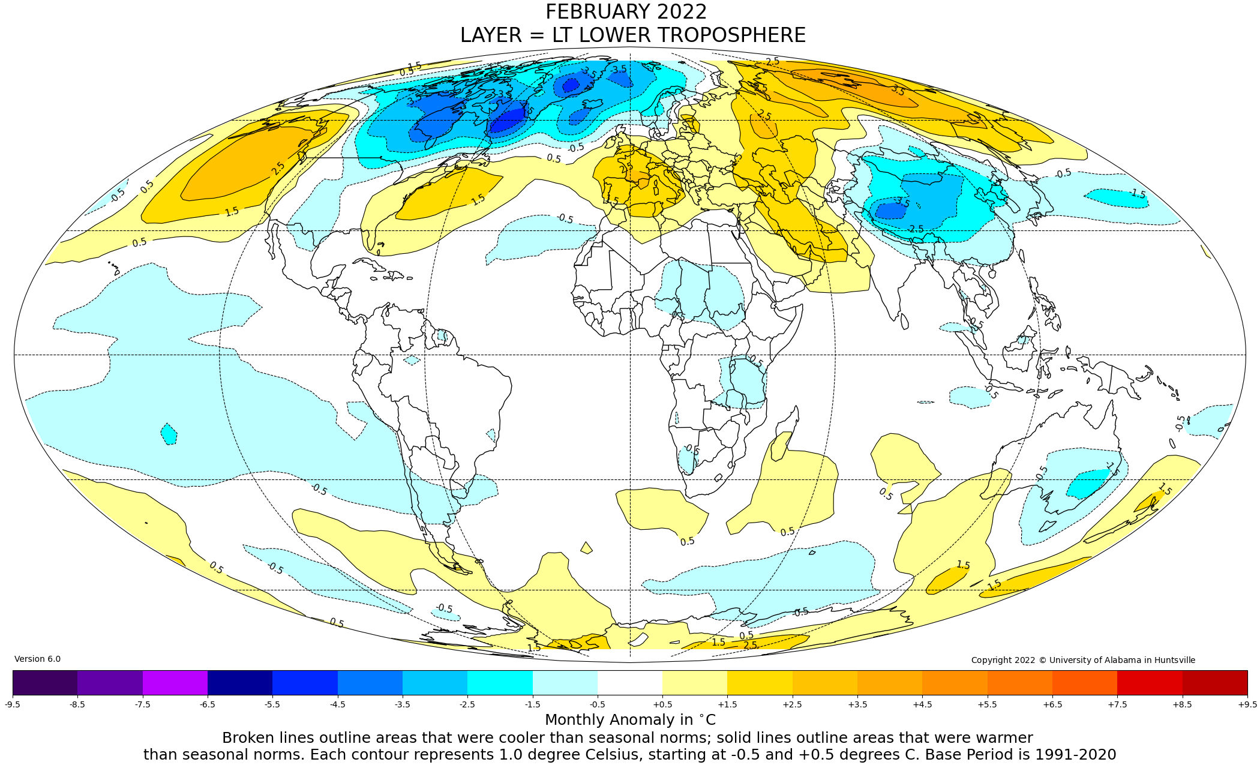
Figure. Lower tropospheric temperature anomalies for February 2022

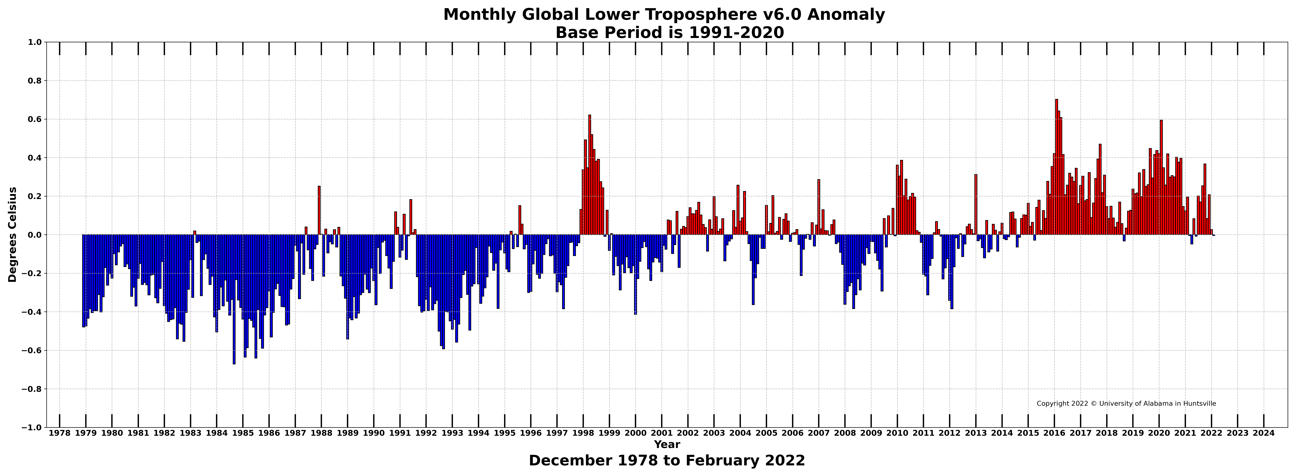

Figure. Bar chart of global monthly lower tropospheric temperature anomalies.

