April 1, 2021

Vol. 31, No. 12

For Additional Information:
Dr. John Christy, (256) 961-7763
christy@nsstc.uah.edu
Dr. Roy Spencer, (256) 961-7960
spencer@nsstc.uah.edu

Global Temperature Report: March 2021
(New Reference Base, 1991-2020)

Global climate trend since Dec. 1 1978: +0.14 C per decade

March Temperatures (preliminary)

Global composite temp.: -0.01 C (-0.02 °F) below seasonal average

Northern Hemisphere: +0.12 C (+0.22 °F) above seasonal average

Southern Hemisphere: -0.14 C (-0.25 °F) below seasonal average

Tropics: -0.29 C (-0.52 °F) below seasonal average

February Temperatures (final)

Global composite temp.: +0.20 C (+0.36 °F) above seasonal average

Northern Hemisphere: +0.31 C (+0.56 °F) above seasonal average

Southern Hemisphere: +0.08 C (+0.14 °F) above seasonal average

Tropics: -0.14 C (-0.25 °F) below seasonal average

Notes on data released April 1, 2021 (v6.0, with new reference base)

The La Niña-induced cooling is still making its presence felt as the global average temperature anomaly dipped further from February’s value to below average for the first time since Sep 2018 and is the coolest March since 2014. This period (Feb – May) is usually the coolest in the atmosphere for a typical La Niña episode as the temperatures then tend to recover from the previous several months of less-than-normal heating from the Pacific Ocean. NOAA reports that the water temperatures in the tropical Pacific are still below average, but are moving in the direction of warming now. (https://www.cpc.ncep.noaa.gov/products/analysis_monitoring/lanina/enso_evolution-status-fcsts-web.pdf)

The global average of -0.01 °C (-0.02 °F) represents a cooling from February of 0.21 °C led by declines in the atmosphere’s temperature over the oceans. By contrast, the NH atmospheric temperature over land saw no change compared with last month while the air over the SH land actually warmed from February. But, since the earth is 70+% ocean, the ocean’s areal influence had the most impact on the global average.

The warmest grid cell, in terms of departure from average, was +4.2 °C (+7.6 °F) over East Antarctica near the Princess Astrid Coast. Anomalous warmth was seen from eastern North America to Iceland, far south in East Antarctica, and starting in Saudi Arabia eastward through China, Japan and the North Pacific Ocean.

The coldest departure from average was over the Laptev Sea off the northern Russian coast at -4.0 °C (-7.2 °F). In addition to the vast area of cooler than average air over the Pacific Ocean that stretched from Australia to the western US, cooler than average conditions were experience in southern Europe NE to Russia and then east to Alaska. South America was slightly cooler than usual as well as western Antarctica.

The conterminous US warmed from February’s cold to +0.59 °C (+1.06 °F). However, adding in Alaska’s below average temperatures puts the 49-state average at +0.30 °C (+0.54 °F) which is very close to the average. [We don’t include Hawaii in the US results because its land area is less than that of a satellite grid square, so it would have virtually no impact on the overall national results.]

New Reference Base Jan 2021. As noted in the Jan 2021 GTR, the situation comes around every 10 years when the reference period or “30-year normal” that we use to calculate the departures is redefined. With that, we have averaged the absolute temperatures over the period 1991-2020, in accordance with the World Meteorological Organization’s guidelines, and use this as the new base period. This allows the anomalies to relate more closely to the experience of the average person, i.e. the climate of the last 30 years. Due to the rising trend of global and regional temperatures, the new normals are a little warmer than before, i.e. the global average temperature for Januaries for 1991-2020 is 0.14 °C warmer than the average for Januaries during 1981-2010. So, the new departures from this now warmer average will appear to be cooler, but this is an artifact of simply applying a new base period. It is important to remember that changes over time periods, such as a trend value or the relative difference of one year to the next, will not change. Think about it this way, all we’ve done is to take the entire time series and shifted it down a little.

To-Do List: There has been a delay in our ability to utilize and merge the new generation of microwave sensors (ATMS) on the NPP and JPSS satellites. As of now, the calibration equations applied by the agency have changed at least twice, so that the data stream contains inhomogeneities which obviously impact the type of measurements we seek. We are hoping this is resolved soon with a dataset that is built with a single, consistent set of calibration equations. In addition, the current non-drifting satellite operated by the Europeans, MetOP-B, has not yet been adjusted or “neutralized” for its seasonal peculiarities related to its unique equatorial crossing time (0930). While these MetOP-B peculiarities do not affect the long-term global trend, they do introduce error within a particular year in specific locations over land.

As part of an ongoing joint project between UAH, NOAA and NASA, Christy and Dr. Roy Spencer, an ESSC principal scientist, use data gathered by advanced microwave sounding units on NOAA, NASA and European satellites to produce temperature readings for almost all regions of the Earth. This includes remote desert, ocean and rain forest areas where reliable climate data are not otherwise available. Drs. Danny Braswell Rob Junod assist in the preparation of these reports.

The satellite-based instruments measure the temperature of the atmosphere from the surface up to an altitude of about eight kilometers above sea level. Once the monthly temperature data are collected and processed, they are placed in a "public" computer file for immediate access by atmospheric scientists in the U.S. and abroad.

The complete version 6 lower troposphere dataset is available here:

http://www.nsstc.uah.edu/data/msu/v6.0/tlt/uahncdc_lt_6.0.txt

Archived color maps of local temperature anomalies are available on-line at:

http://nsstc.uah.edu/climate/

Neither Christy nor Spencer receives any research support or funding from oil, coal or industrial companies or organizations, or from any private or special interest groups. All of their climate research funding comes from federal and state grants or contracts.

--30—

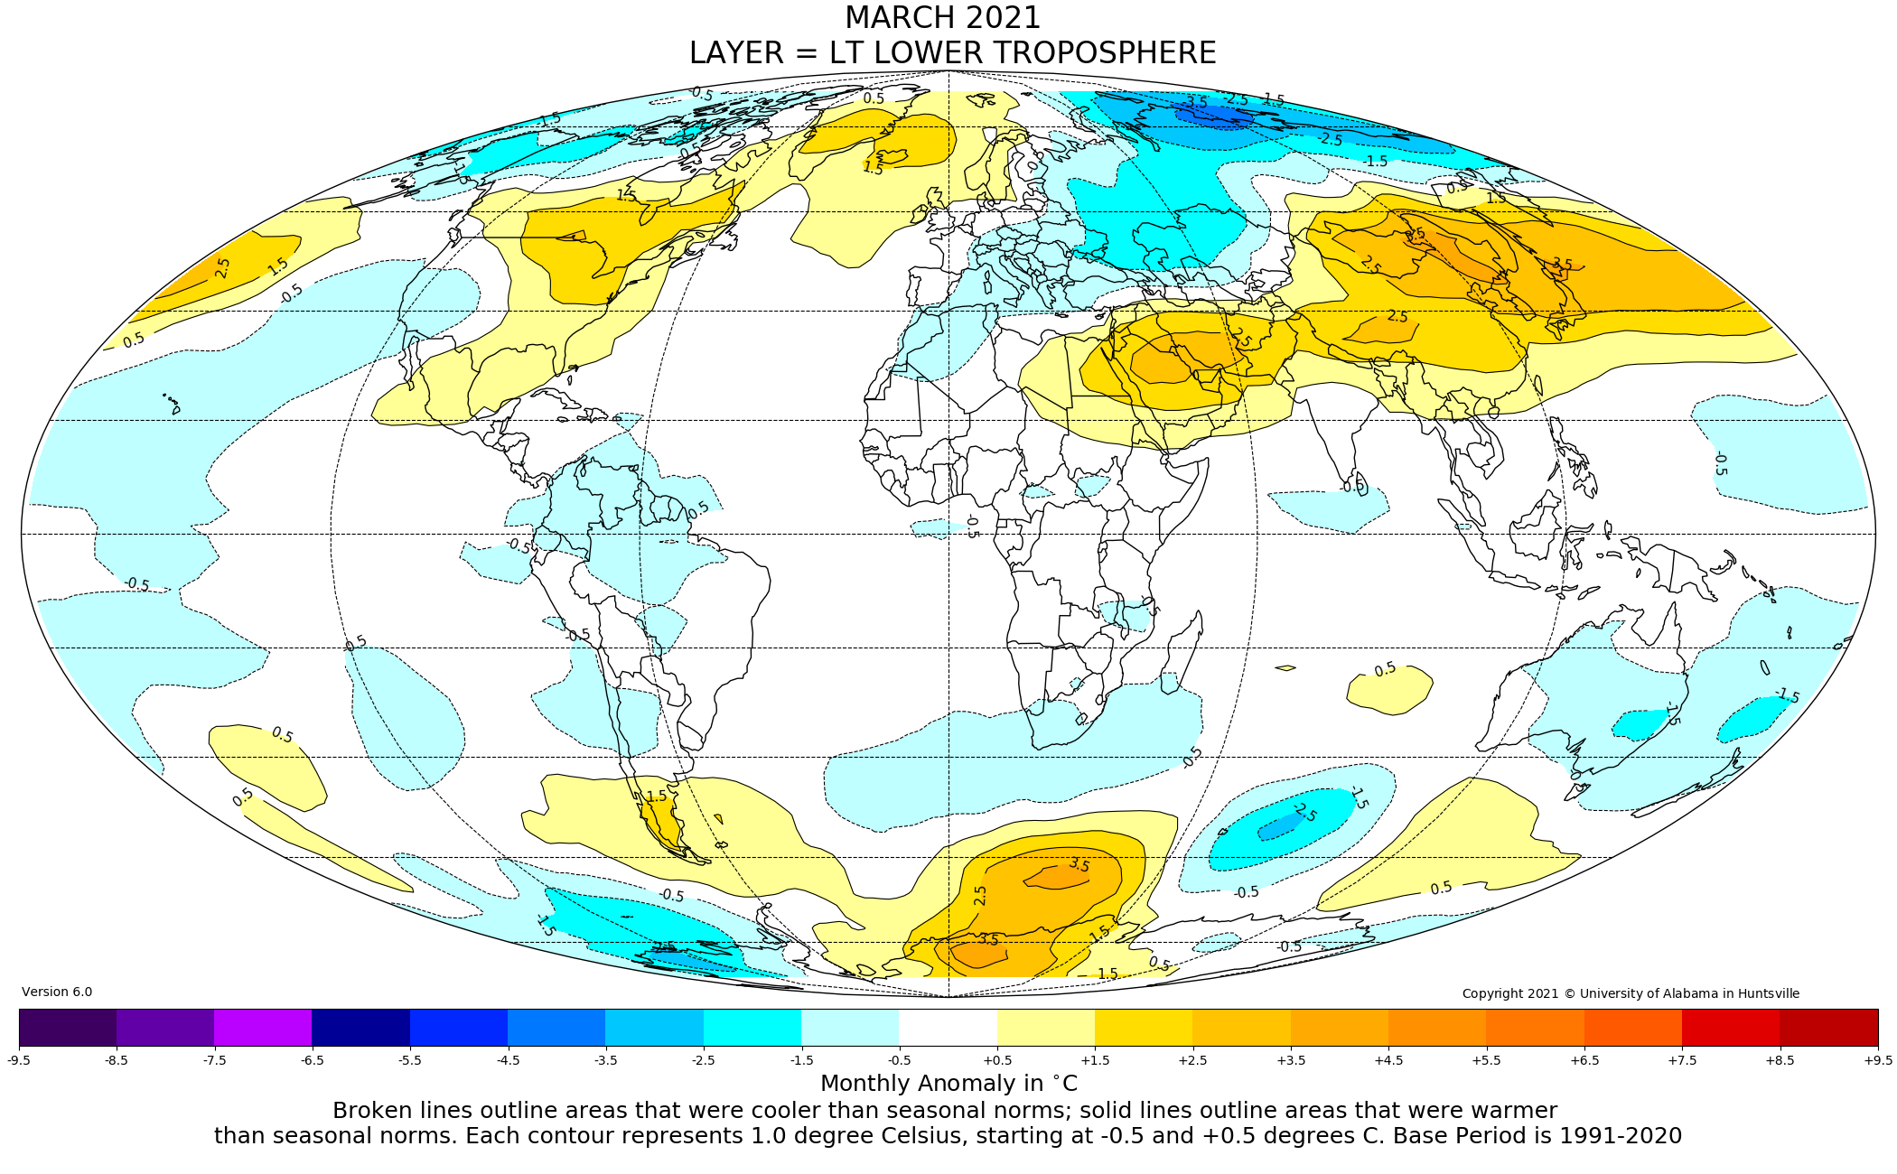
Figure. Lower tropospheric temperature anomalies for March 2021

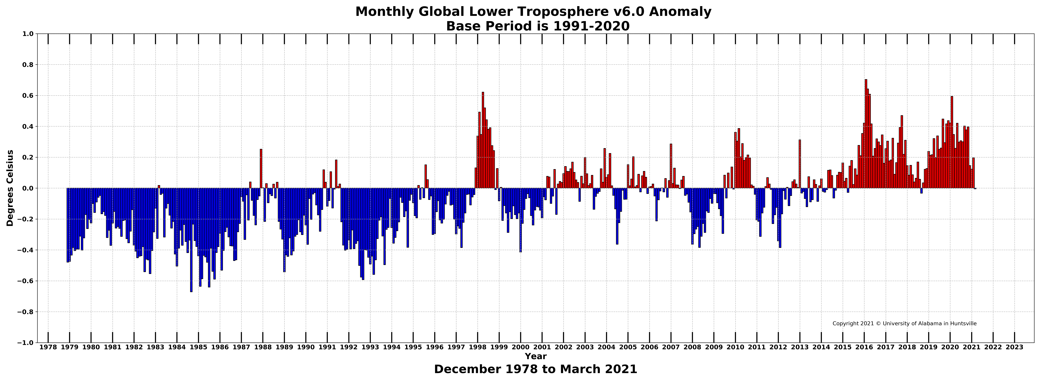
Figure. Bar chart of global monthly lower tropospheric temperature anomalies.

