August 2, 2021

Vol. 32, No. 4

For Additional Information:
Dr. John Christy, (256) 961-7763
christy@nsstc.uah.edu
Dr. Roy Spencer, (256) 961-7960
spencer@nsstc.uah.edu

Global Temperature Report: July 2021
(New Reference Base, 1991-2020)

Global climate trend since Dec. 1 1978: +0.14 C per decade

July Temperatures (preliminary)

Global composite temp.: +0.20 C (+0.36 °F) above seasonal average

Northern Hemisphere: +0.33 C (+0.59 °F) above seasonal average

Southern Hemisphere: +0.07 C (+0.13°F) above seasonal average

Tropics: +0.13 C (+0.23 °F) above seasonal average

June Temperatures (final)

Global composite temp.: -0.01 C (-0.02 °F) below seasonal average

Northern Hemisphere: +0.31 C (+0.56 °F) above seasonal average

Southern Hemisphere: -0.32 C (-0.58°F) below seasonal average

Tropics: -0.14 C (-0.25 °F) below seasonal average

Notes on data released August 2, 2021 (v6.0, with new reference base)

The global temperature departure from average rose to +0.20 C (+0.36 °F) from -0.01 C (-0.02 °F) in June, matching the +0.20 C value observed in February. In between February and July were four months of slightly cooler than average temperatures. The Southern Hemisphere experienced the bulk of this change, as it warmed from -0.32 C in June to +0.07 C this month. A major contributor to the warming was Antarctica as the month-to-month temperature change was +1.84 C (-1.54 C to +0.30 C). Such, month-to-month changes in Antarctica though can be large, as much as +3.54 C observed from May to June in 1994. The Northern Hemisphere temperature was virtually unchanged from June.

As noted last month, atmospheric temperatures bounce around from month to month relative to the slower changes created by the El Niño/La Niña cycle of the tropical Pacific Ocean temperatures, so such variations are normal. Though confidence in predictions at this time is low, NOAA is indicating a possible (~60%) return to cool La Niña conditions for the coming Boreal winter with their recently issued “La Niña Watch”. Back-to-back La Niñas are not unusual. So, it is possible that the global temperature may dip back to average or below for several months despite the uptick in temperature in July. This is a possibility, not a prediction. To keep track of the latest weekly summary of the El Niño/La Niña cycle see:

https://www.cpc.ncep.noaa.gov/products/analysis_monitoring/lanina/enso_evolution-status-fcsts-web.pdf.

The warmest region, in terms of the monthly departure from average, was near the far-east Russian seaport of De-Kastri where the value was +3.1 C (+5.6 °F). This warmth was part of a series of warm regions in the northern hemisphere mid-latitudes that affected (from west to east) western North America, Iceland to Ukraine through northern China and eastern Russia. Australia and parts of Antarctica, Argentina and the South Pacific saw warmth.

The coldest grid cell occurred near the Antarctica coastal region south of Australia with a departure from average of -2.3 C (-4.2 °F). Several colder than average regions were found in the southern oceans as well as around the Arctic Circle. The tropics were near average.

The pattern of warmer temperatures in the western conterminous US vs the eastern states continued in July. There is some suggestion this persistent pattern is related to the waning effects of La Niña. Overall the 48-state average was +0.58 C (+1.04 °F), a good bit cooler than June’s +1.44 C. Adding in Alaska’s temperature doesn’t change the July value too much with the 49-state average coming in at +0.60 °C (+1.08 °F). [We don’t include Hawaii in the US results because its land area is less than that of a satellite grid square, so it would have virtually no impact on the overall national results.]

New Reference Base Jan 2021. As noted in the Jan 2021 GTR, the situation comes around every 10 years when the reference period or “30-year normal” that we use to calculate the departures is redefined. With that, we have averaged the absolute temperatures over the period 1991-2020, in accordance with the World Meteorological Organization’s guidelines, and use this as the new base period. This allows the anomalies to relate more closely to the experience of the average person, i.e. the climate of the last 30 years. Due to the rising trend of global and regional temperatures, the new normals are a little warmer than before, i.e. the global average temperature for Januaries for 1991-2020 is 0.14 °C warmer than the average for Januaries during 1981-2010. So, the new departures from this now warmer average will appear to be cooler, but this is an artifact of simply applying a new base period. It is important to remember that changes over time periods, such as a trend value or the relative difference of one year to the next, will not change. Think about it this way, all we’ve done is to take the entire time series and shifted it down a little.

To-Do List: There has been a delay in our ability to utilize and merge the new generation of microwave sensors (ATMS) on the NPP and JPSS satellites. As of now, the calibration equations applied by the agency have changed at least twice, so that the data stream contains inhomogeneities which obviously impact the type of measurements we seek. We are hoping this is resolved soon with a dataset that is built with a single, consistent set of calibration equations. In addition, the current non-drifting satellite operated by the Europeans, MetOP-B, has not yet been adjusted or “neutralized” for its seasonal peculiarities related to its unique equatorial crossing time (0930). While these MetOP-B peculiarities do not affect the long-term global trend, they do introduce error within a particular year in specific locations over land.

As part of an ongoing joint project between UAH, NOAA and NASA, Christy and Dr. Roy Spencer, an ESSC principal scientist, use data gathered by advanced microwave sounding units on NOAA, NASA and European satellites to produce temperature readings for almost all regions of the Earth. This includes remote desert, ocean and rain forest areas where reliable climate data are not otherwise available. Drs. Danny Braswell and Rob Junod assist in the preparation of these reports.

The satellite-based instruments measure the temperature of the atmosphere from the surface up to an altitude of about eight kilometers above sea level. Once the monthly temperature data are collected and processed, they are placed in a "public" computer file for immediate access by atmospheric scientists in the U.S. and abroad.

The complete version 6 lower troposphere dataset is available here:

http://www.nsstc.uah.edu/data/msu/v6.0/tlt/uahncdc_lt_6.0.txt

Archived color maps of local temperature anomalies are available on-line at:

http://nsstc.uah.edu/climate/

Neither Christy nor Spencer receives any research support or funding from oil, coal or industrial companies or organizations, or from any private or special interest groups. All of their climate research funding comes from federal and state grants or contracts.

--30—

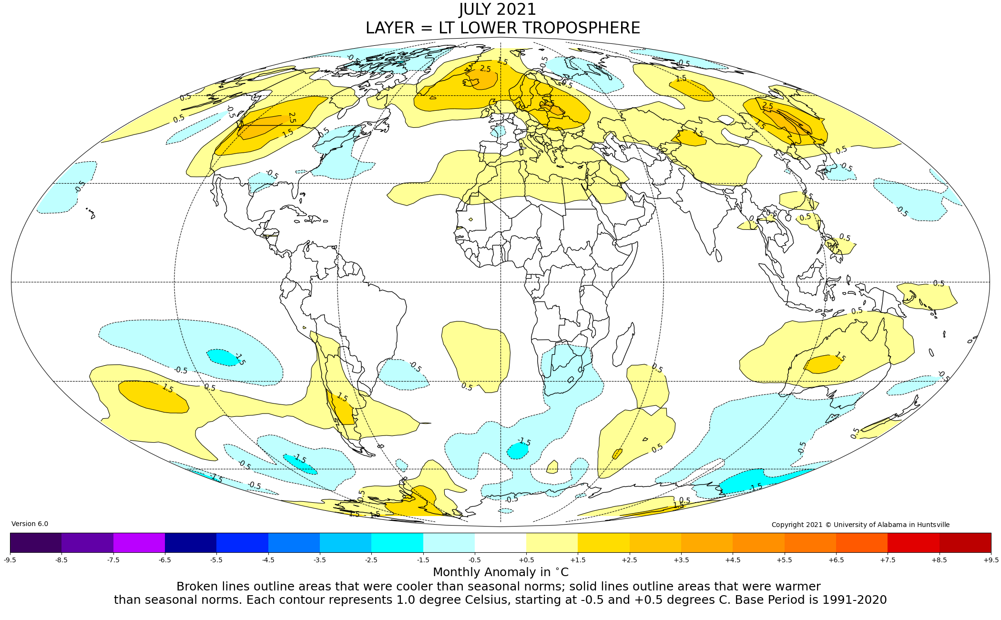

Figure. Lower tropospheric temperature anomalies for July 2021

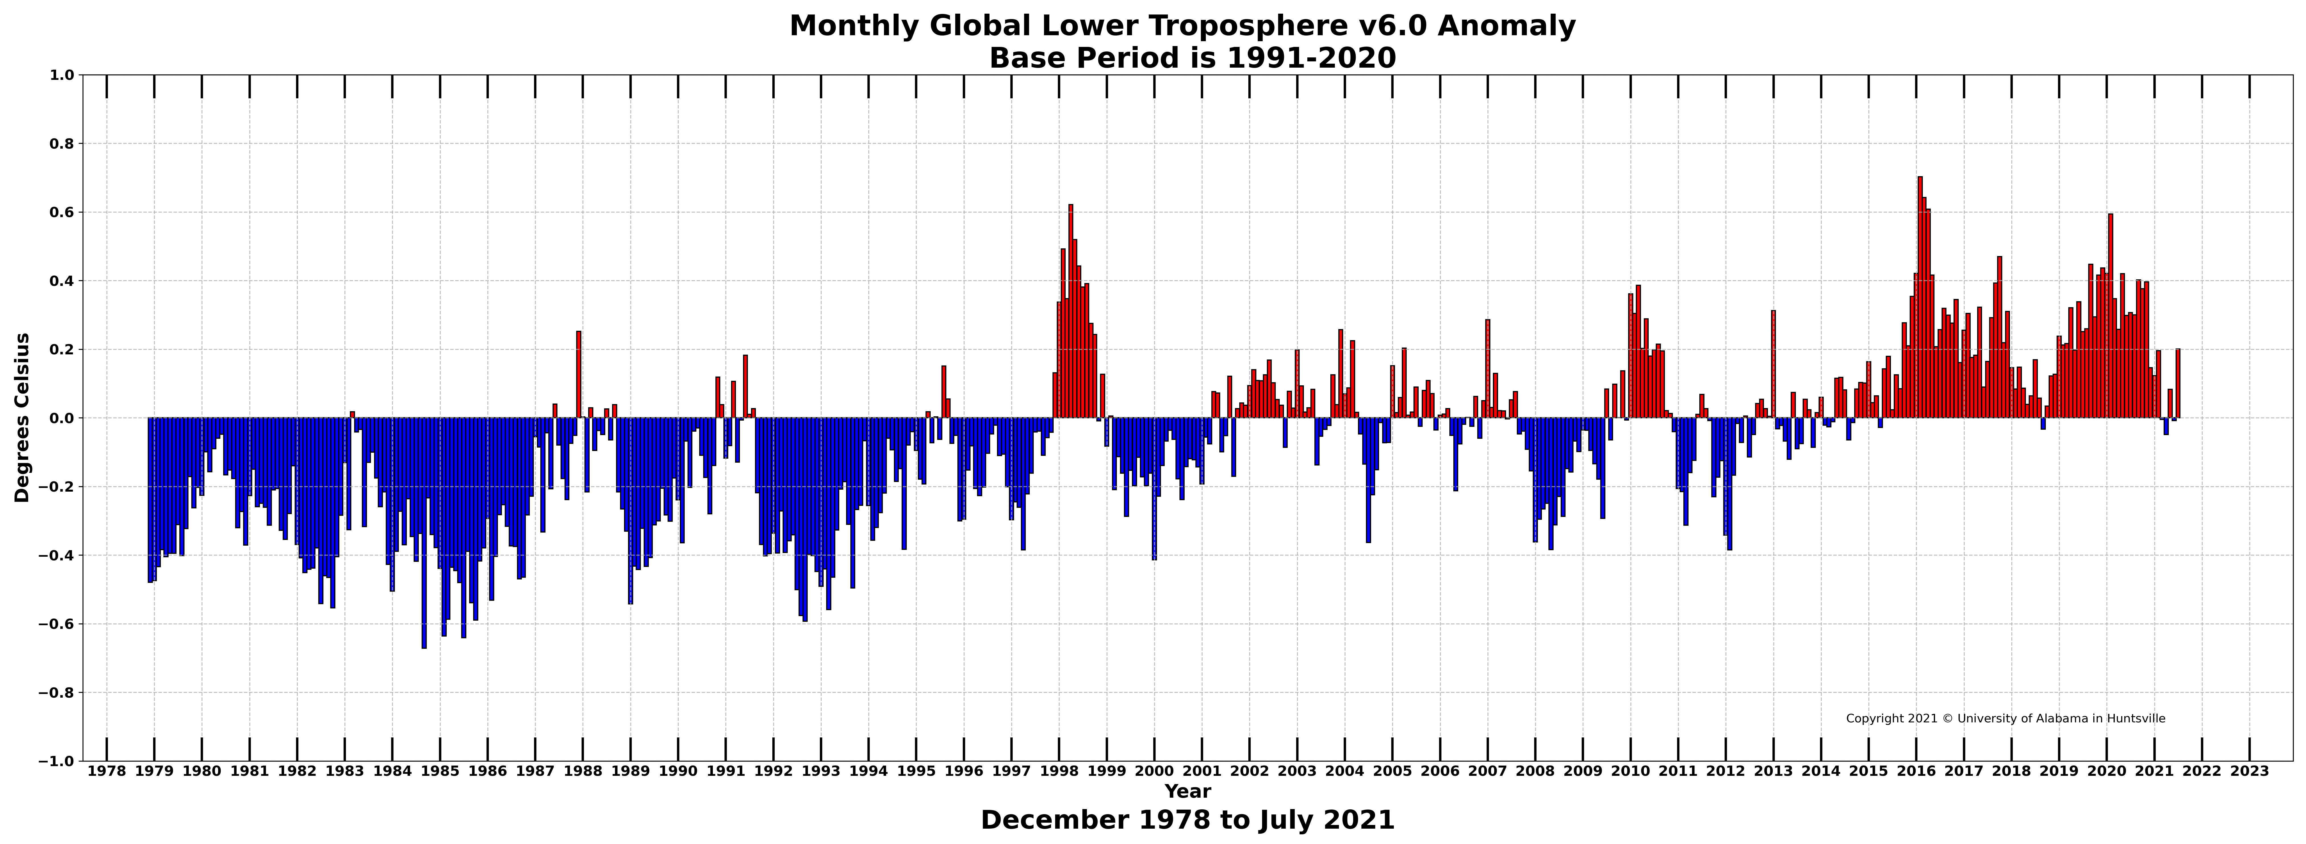

Figure. Bar chart of global monthly lower tropospheric temperature anomalies.

