October 5, 2021

Vol. 32, No. 6

For Additional Information:
Dr. John Christy, (256) 961-7763
christy@nsstc.uah.edu
Dr. Roy Spencer, (256) 961-7960
spencer@nsstc.uah.edu

Global Temperature Report: September 2021
(New Reference Base, 1991-2020)

Global climate trend since Dec. 1 1978: +0.14 C per decade

September Temperatures (preliminary)

Global composite temp.: +0.25 C (+0.45 °F) above seasonal average

Northern Hemisphere: +0.18 C (+0.32 °F) above seasonal average

Southern Hemisphere: +0.33 C (+0.59°F) above seasonal average

Tropics: +0.09 C (+0.16 °F) above seasonal average

August Temperatures (final)

Global composite temp.: +0.17 C (+0.31 °F) above seasonal average

Northern Hemisphere: +0.26 C (+0.47 °F) above seasonal average

Southern Hemisphere: +0.08 C (+0.14°F) above seasonal average

Tropics: +0.07 C (+0.13 °F) above seasonal average

Notes on data released October 5, 2021 (v6.0, with new reference base)

The global temperature departure from average inched up from August’s value to +0.25 C (+0.45 °F) due in large part to an increase in the Southern Hemisphere temperature from +0.08 C to +0.33 C. The Northern Hemisphere cooled slightly and the tropics were essentially unchanged from August. Of interest in terms of change is the Southern Hemisphere land areas that, though small compared with the NH, saw increased warmth especially in South America. The tropics were largely near average with a few below average pockets around 20°N latitude. We will be watching for a further drop in the bulk atmospheric temperature in this region as the sea water temperatures are projected to decline as part of the La Niña episode.

The confidence in the appearance of La Niña this coming NH winter has increased a bit to 70-80% as NOAA continues with its “La Niña Watch”. Back-to-back La Niñas are not unusual, so it is possible that the global temperature may dip back to average or below in several of the coming months despite the uptick in temperature in the past three months in both the atmosphere as reported here and in the tropical sea surface temperatures reported by NOAA. This potential fall in global temperatures for the coming months is now becoming more likely but won’t really be evident until early 2022. To keep track of the latest weekly summary of the El Niño/La Niña cycle see:

https://www.cpc.ncep.noaa.gov/products/analysis_monitoring/lanina/enso_evolution-status-fcsts-web.pdf.

The warmest region, in terms of the monthly departure from average, was +3.2 C (+5.8 °F) over eastern Russia. There were several areas of almost equal warm departures centered over northern Afghanistan, western conterminous U.S. northeastward to eastern Canada, Paraguay, and the South Pacific Ocean.

The coldest grid cell was centered on the Greenland Icecap dropping to -4.2 C (-7.5 °F). Cooler than average regions were also found either side of the Dateline north of 50 °N, far western Russia and east of Northern Japan.

The pattern of warmer temperatures in the western conterminous US vs the eastern states continued in September. As noted in previous months’ reports, there is some suggestion this persistent pattern is related to the indirect effects of La Niña. Overall the 48-state average was above average at +0.67 C (+1.21 °F). Alaska was part of the below-average temperature region near the Dateline so adding in its influence drops the 49-state average to +0.32 °C (+0.58 °F). [We don’t include Hawaii in the US results because its land area is less than that of a satellite grid square, so it would have virtually no impact on the overall national results.]

New Reference Base Jan 2021. As noted in the Jan 2021 GTR, the situation comes around every 10 years when the reference period or “30-year normal” that we use to calculate the departures is redefined. With that, we have averaged the absolute temperatures over the period 1991-2020, in accordance with the World Meteorological Organization’s guidelines, and use this as the new base period. This allows the anomalies to relate more closely to the experience of the average person, i.e. the climate of the last 30 years. Due to the rising trend of global and regional temperatures, the new normals are a little warmer than before, i.e. the global average temperature for Januaries for 1991-2020 is 0.14 °C warmer than the average for Januaries during 1981-2010. So, the new departures from this now warmer average will appear to be cooler, but this is an artifact of simply applying a new base period. It is important to remember that changes over time periods, such as a trend value or the relative difference of one year to the next, will not change. Think about it this way, all we’ve done is to take the entire time series and shifted it down a little.

To-Do List: There has been a delay in our ability to utilize and merge the new generation of microwave sensors (ATMS) on the NPP and JPSS satellites. As of now, the calibration equations applied by the agency have changed at least twice, so that the data stream contains inhomogeneities which obviously impact the type of measurements we seek. We are hoping this is resolved soon with a dataset that is built with a single, consistent set of calibration equations. In addition, the current non-drifting satellite operated by the Europeans, MetOP-B, has not yet been adjusted or “neutralized” for its seasonal peculiarities related to its unique equatorial crossing time (0930). While these MetOP-B peculiarities do not affect the long-term global trend, they do introduce error within a particular year in specific locations over land.

As part of an ongoing joint project between UAH, NOAA and NASA, Christy and Dr. Roy Spencer, an ESSC principal scientist, use data gathered by advanced microwave sounding units on NOAA, NASA and European satellites to produce temperature readings for almost all regions of the Earth. This includes remote desert, ocean and rain forest areas where reliable climate data are not otherwise available. Drs. Danny Braswell and Rob Junod assist in the preparation of these reports.

The satellite-based instruments measure the temperature of the atmosphere from the surface up to an altitude of about eight kilometers above sea level. Once the monthly temperature data are collected and processed, they are placed in a "public" computer file for immediate access by atmospheric scientists in the U.S. and abroad.

The complete version 6 lower troposphere dataset is available here:

http://www.nsstc.uah.edu/data/msu/v6.0/tlt/uahncdc_lt_6.0.txt

Archived color maps of local temperature anomalies are available on-line at:

http://nsstc.uah.edu/climate/

Neither Christy nor Spencer receives any research support or funding from oil, coal or industrial companies or organizations, or from any private or special interest groups. All of their climate research funding comes from federal and state grants or contracts.

--30—

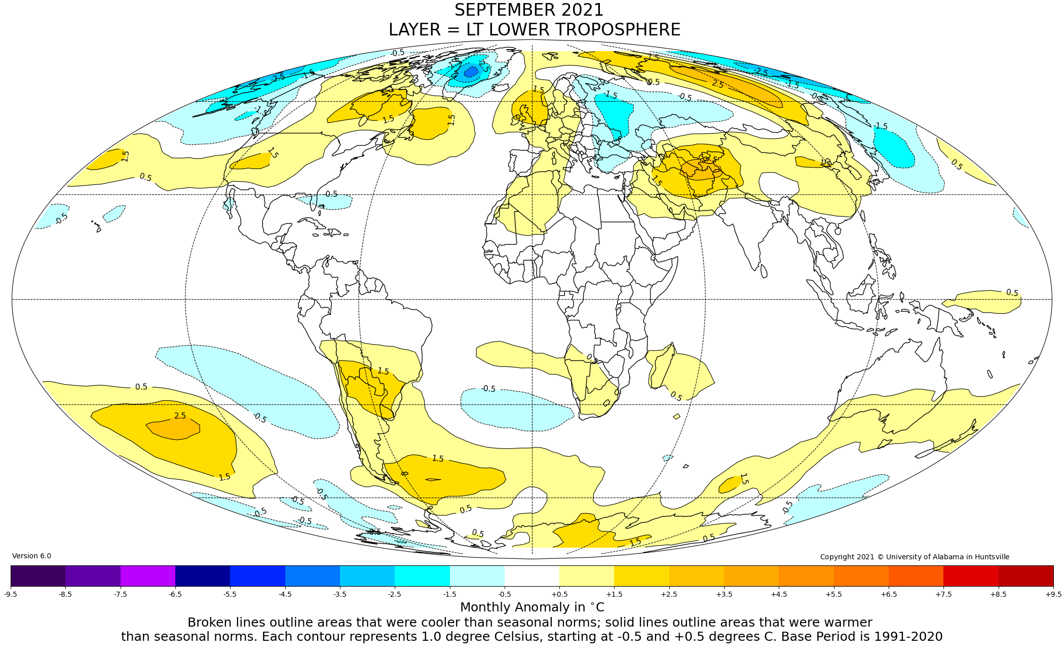

Figure. Lower tropospheric temperature anomalies for September 2021

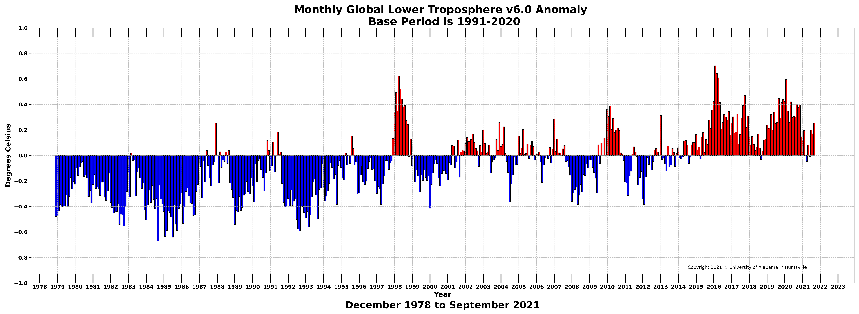

Figure. Bar chart of global monthly lower tropospheric temperature anomalies.

