June 2, 2021

Vol. 32, No. 2

For Additional Information:
Dr. John Christy, (256) 961-7763
christy@nsstc.uah.edu
Dr. Roy Spencer, (256) 961-7960
spencer@nsstc.uah.edu

Global Temperature Report: May 2021
(New Reference Base, 1991-2020)

Global climate trend since Dec. 1 1978: +0.14 C per decade

May Temperatures (preliminary)

Global composite temp.: +0.08 C (+0.14 °F) above seasonal average

Northern Hemisphere: +0.14 C (+0.25 °F) above seasonal average

Southern Hemisphere: +0.03 C (+0.05 °F) above seasonal average

Tropics: +0.06 C (+0.11 °F) above seasonal average

April Temperatures (final)

Global composite temp.: -0.05 C (-0.09 °F) below seasonal average

Northern Hemisphere: +0.05 C (+0.09 °F) above seasonal average

Southern Hemisphere: -0.15 C (-0.27 °F) below seasonal average

Tropics: -0.28 C (-0.50 °F) below seasonal average

Notes on data released June 2, 2021 (v6.0, with new reference base)

With the modest warming seen in May, we are likely on the way out of the current La Niña cycle whose cool tropical Pacific waters helped to produce lower atmospheric temperatures since late last year. But since mid-February, the bulk sea water temperatures in the tropics have been climbing and are now above average, likely indicating the atmosphere will see more above normal temperatures, at least for the next few months. The global departure from average of +0.08 °C (+0.14 °F) represents a slight warming from April with the area of greatest monthly increase in the tropics (-0.28 to +0.08 °C).

The warmest grid cell, in terms of monthly departure from average, was +3.9 °C (+7.0 °F) near the city of Sterlitamak in southwestern Russia which was part of a large arch of anomalous warmth that began in North Africa, then to Turkey through Kazakhstan north and westward through western Russia. The atmosphere above the northwestern Pacific Ocean and far South Atlantic were also well-above normal.

The minimum temperature was -2.8 °C (-5.0 °F) found just northeast of Zucchelli in East Antarctica. Another cold spot occurred above southeastern England and the Netherlands which anchored a broad area of cooler than average temperatures that stretched from the central US through the North Atlantic to the Arctic. Other colder than normal temperatures were found in alternating regions around the globe in the high southern latitudes as well as northern India, southeast Russia and northern Canada. The tropics now show no departures from average of significance.

The central and eastern conterminous US were cooler than average that led to an average departure overall that was below normal at -0.41 °C (-0.74 °F). This pattern of warmth on the west coast and coolness in the eastern regions has been somewhat persistent this year. Adding in Alaska’s temperature doesn’t change to value much with the 49-state average coming in at -0.39 °C (-0.70 °F). [We don’t include Hawaii in the US results because its land area is less than that of a satellite grid square, so it would have virtually no impact on the overall national results.]

New Reference Base Jan 2021. As noted in the Jan 2021 GTR, the situation comes around every 10 years when the reference period or “30-year normal” that we use to calculate the departures is redefined. With that, we have averaged the absolute temperatures over the period 1991-2020, in accordance with the World Meteorological Organization’s guidelines, and use this as the new base period. This allows the anomalies to relate more closely to the experience of the average person, i.e. the climate of the last 30 years. Due to the rising trend of global and regional temperatures, the new normals are a little warmer than before, i.e. the global average temperature for Januaries for 1991-2020 is 0.14 °C warmer than the average for Januaries during 1981-2010. So, the new departures from this now warmer average will appear to be cooler, but this is an artifact of simply applying a new base period. It is important to remember that changes over time periods, such as a trend value or the relative difference of one year to the next, will not change. Think about it this way, all we’ve done is to take the entire time series and shifted it down a little.

To-Do List: There has been a delay in our ability to utilize and merge the new generation of microwave sensors (ATMS) on the NPP and JPSS satellites. As of now, the calibration equations applied by the agency have changed at least twice, so that the data stream contains inhomogeneities which obviously impact the type of measurements we seek. We are hoping this is resolved soon with a dataset that is built with a single, consistent set of calibration equations. In addition, the current non-drifting satellite operated by the Europeans, MetOP-B, has not yet been adjusted or “neutralized” for its seasonal peculiarities related to its unique equatorial crossing time (0930). While these MetOP-B peculiarities do not affect the long-term global trend, they do introduce error within a particular year in specific locations over land.

As part of an ongoing joint project between UAH, NOAA and NASA, Christy and Dr. Roy Spencer, an ESSC principal scientist, use data gathered by advanced microwave sounding units on NOAA, NASA and European satellites to produce temperature readings for almost all regions of the Earth. This includes remote desert, ocean and rain forest areas where reliable climate data are not otherwise available. Drs. Danny Braswell and Rob Junod assist in the preparation of these reports.

The satellite-based instruments measure the temperature of the atmosphere from the surface up to an altitude of about eight kilometers above sea level. Once the monthly temperature data are collected and processed, they are placed in a "public" computer file for immediate access by atmospheric scientists in the U.S. and abroad.

The complete version 6 lower troposphere dataset is available here:

http://www.nsstc.uah.edu/data/msu/v6.0/tlt/uahncdc_lt_6.0.txt

Archived color maps of local temperature anomalies are available on-line at:

http://nsstc.uah.edu/climate/

Neither Christy nor Spencer receives any research support or funding from oil, coal or industrial companies or organizations, or from any private or special interest groups. All of their climate research funding comes from federal and state grants or contracts.

--30—

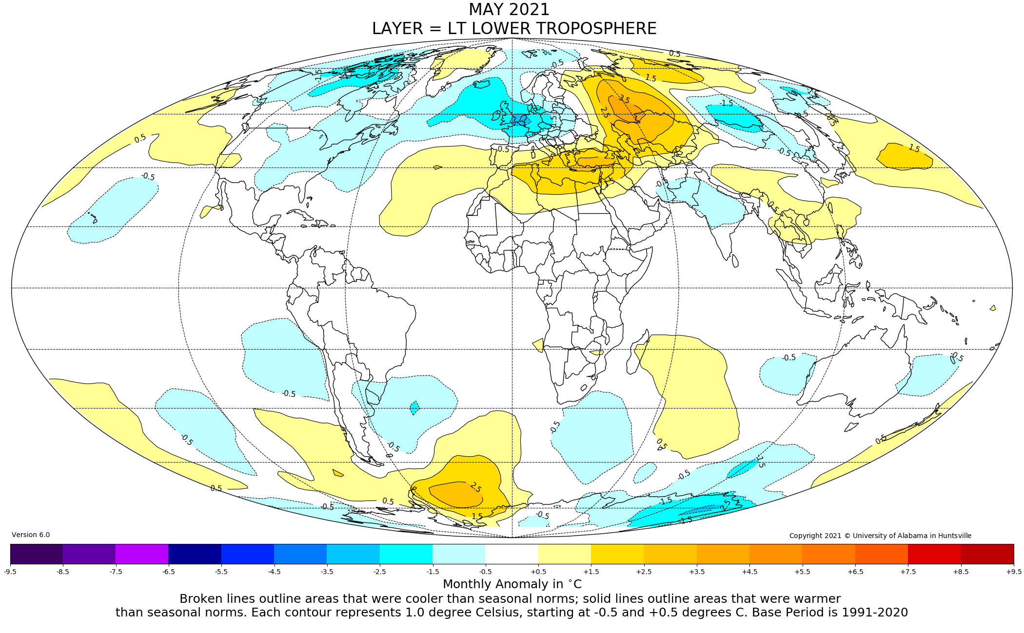

Figure. Lower tropospheric temperature anomalies for April 2021

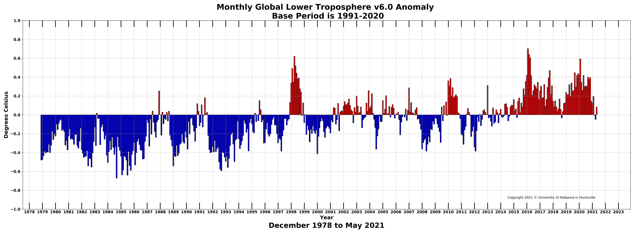

Figure. Bar chart of global monthly lower tropospheric temperature anomalies.

